**HOTEL RENTAL MANAGEMENT**

**TCP Communication (Server Client)**

**Screen Shots for the project**

**WELCOME SCREEN:**

|  |  |
| --- | --- |
| **SERVER:** | **CLIENT** |

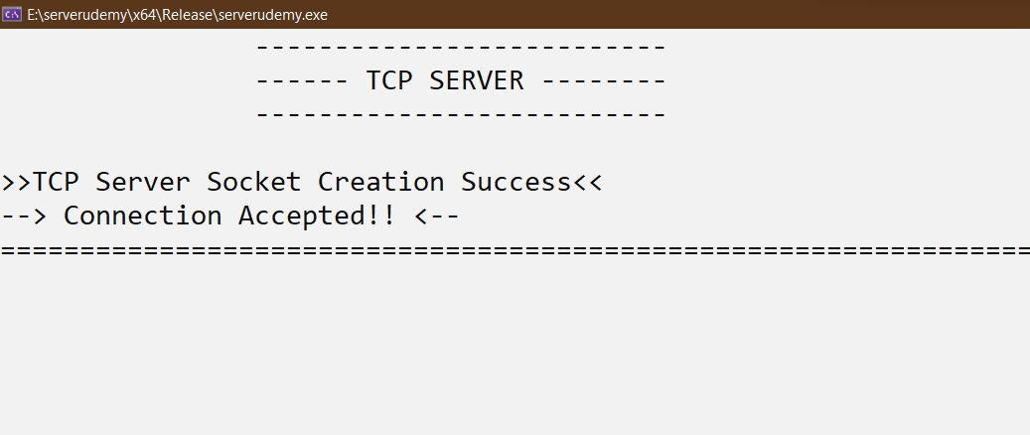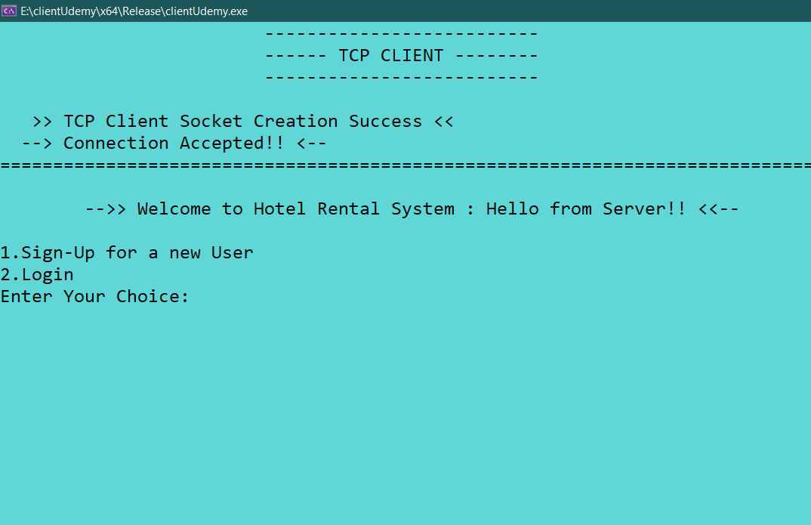

**Sign-Up:**

|  |  |
| --- | --- |
| **SERVER:** | **CLIENT:** |

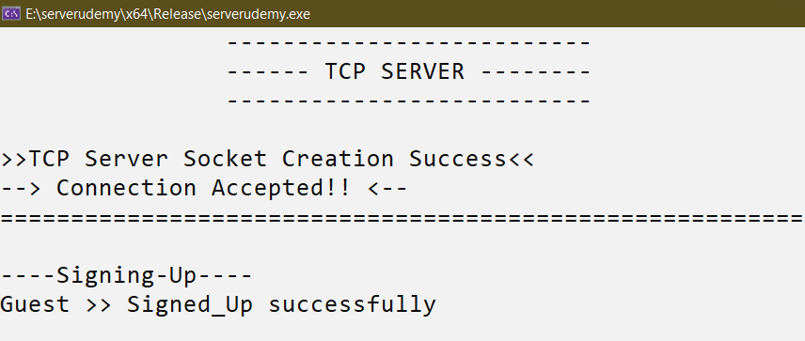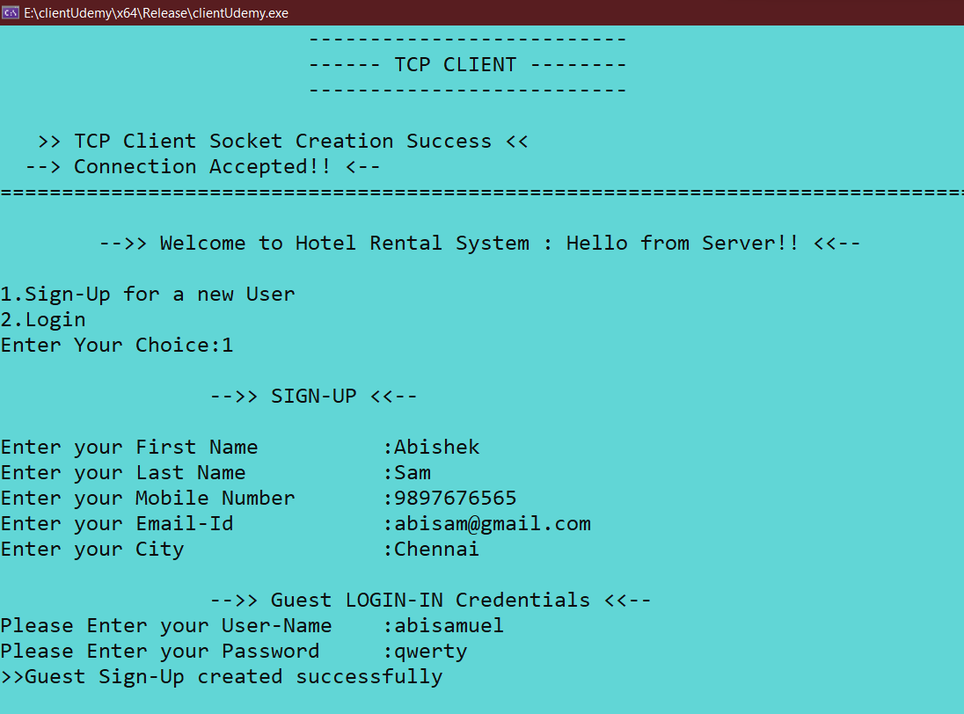

**In Guest Info Table:**



**Log-In:**

|  |  |
| --- | --- |
| **SERVER:** | **CLIENT** |

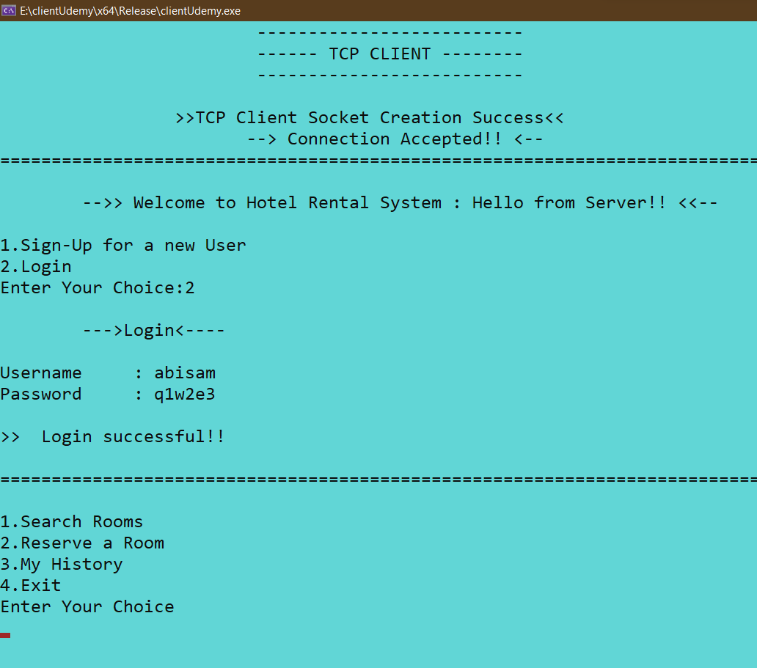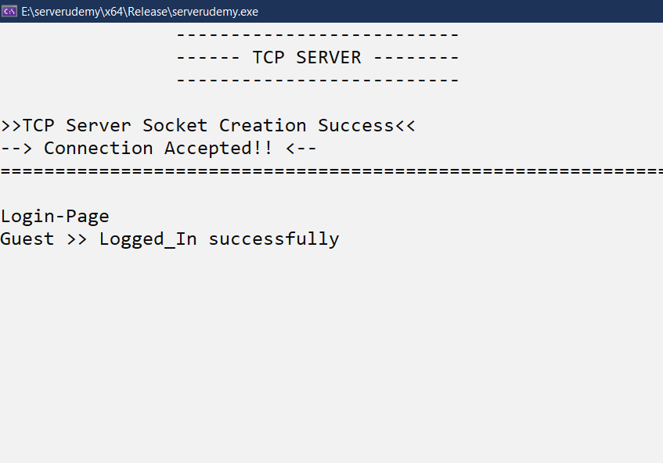

**Reservation of Room:**

|  |  |
| --- | --- |
| **SERVER:** | **CLIENT:** |

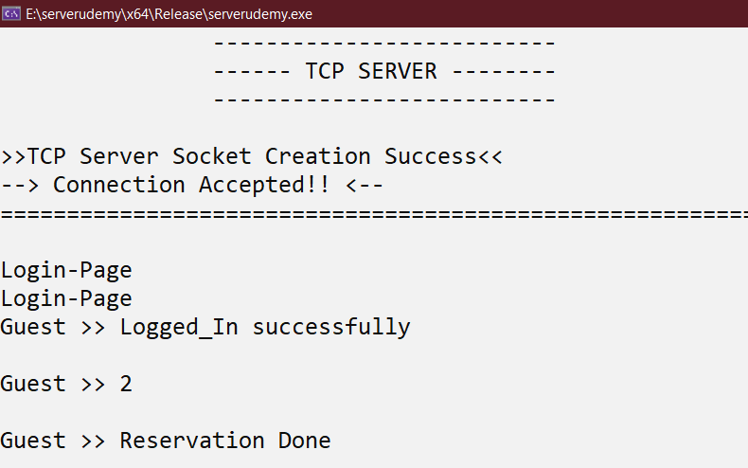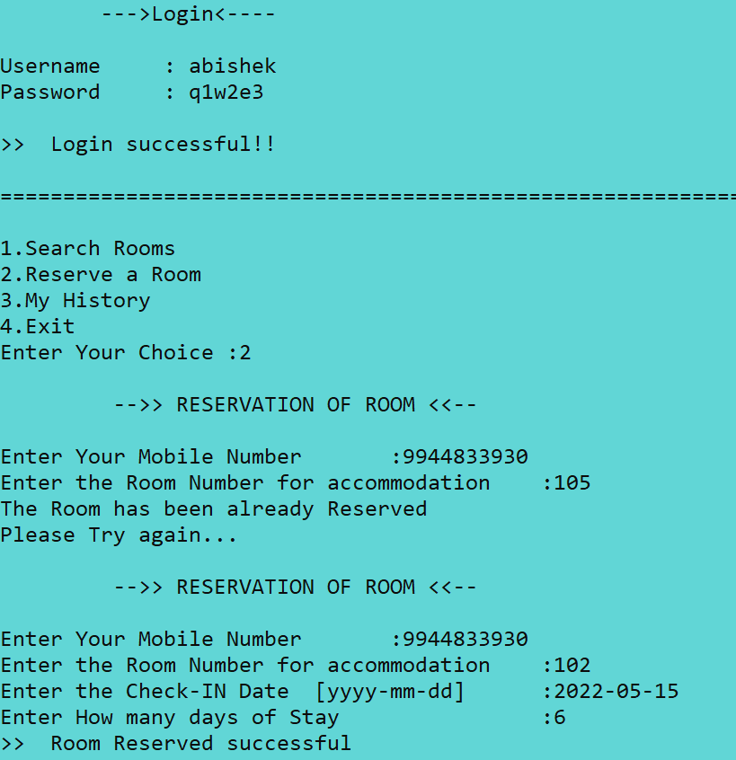

**In Hotel Rooms Information table:**



**In Guest info Table:**



**Room Search:**

|  |  |
| --- | --- |
| **SERVER:** | **CLIENT:** |

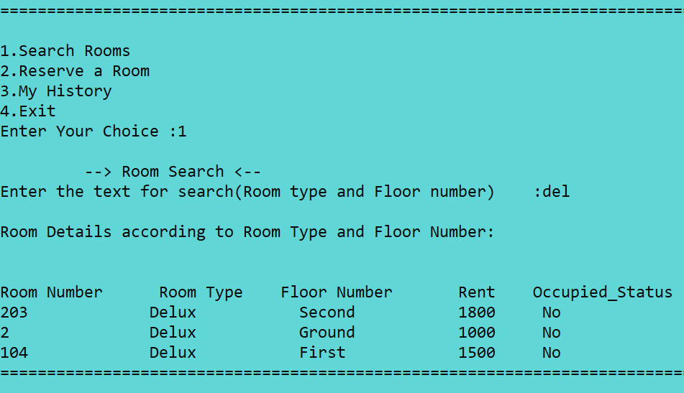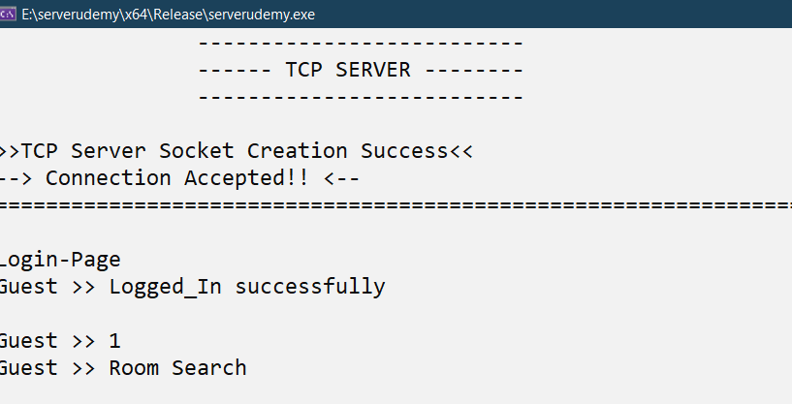

**Guest History:**

**SERVER:**

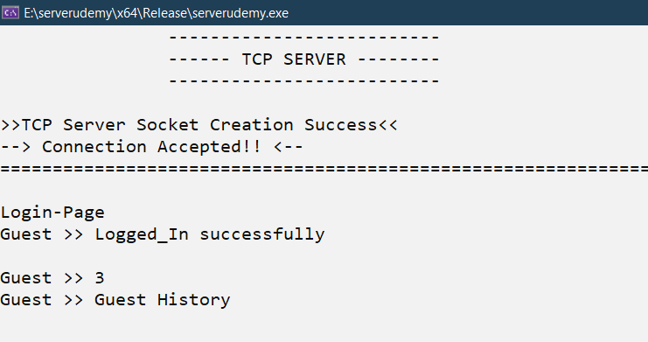

**CLIENT:**

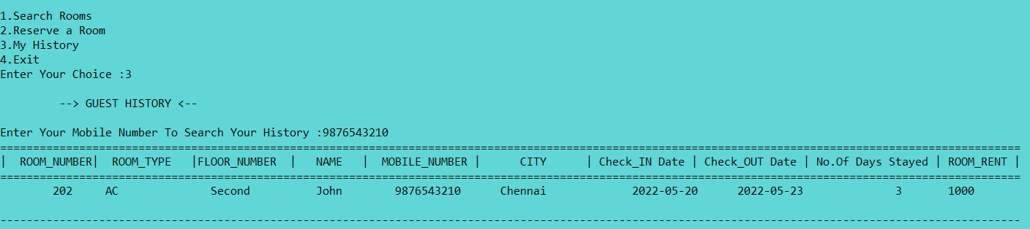

**Exit:**

|  |  |
| --- | --- |
| **SERVER:** | **CLIENT** |

